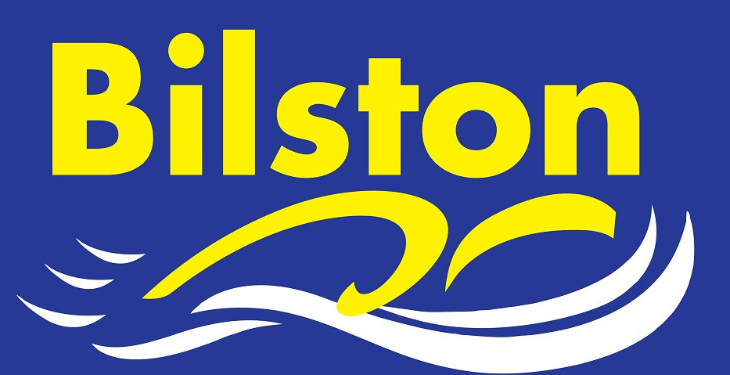
Arena National League

Being in the premier division of Arena National League is a status the club is proud of but it is vital we have a full strength team in round one if we are to stay there. Please make every effort to be available if selected. Whether you are required for individuals or just relays, every swimmer makes a difference in this tough league. Thank you. Luke

Long Course Dates for Coventry for performance swimmers – sign ups will be on noticeboard. (all Saturdays)

17th September 6 – 8pm
22nd October 10 – 12noon
19th November 10 – 12 noon

SEPTEMBER 2016

Back home – thank goodness!!!

Thank you to you all for the tremendous support you have shown during this difficult time whilst Bilston has been closed. Despite the short notice, I was proud that we were able to offer lots and lots of sessions at external pools and even more proud with the super attendances at these sessions. Now we are back at Bilston we will really appreciate the superb facility we have to train in everyday.

Saying goodbye to Pauline

Thank you for your kind words and best wishes over the past few weeks. The turnout at her funeral and wake was absolutely amazing and a fantastic tribute to the lives she touched within the club.

Overall more than £1000 was raised for St Giles Walsall Hospice and I know that there was more than £200 left over for the charity from current members of Bilston SC even after the purchase of the beautiful wreath which was just perfect.

ENSURING OUR YOUNGEST MEMBERS CONTINUE TO RECEIVE HIGH QUALITY COACHING FROM COMMITTED AND SKILLED COACHES

The devastating loss of Pauline in August has left a huge hole in our club and in particular our coaching team. Whilst a team of skilled and qualified staff have been taking up the sessions over the last couple of months I am now eager to appoint a coach with the specific job of taking on many of my mom’s former responsibilities. This person will get to know the children really well, work consistently with them and have a close working relationship with Kim, our junior coach, to ensure that standards do not slip at the bottom end of the club. I spoke at some length in August with my mom about this appointment and she advised me on how to move forwards. I have spoken with our main coaching staff and they have agreed with my mom’s judgment. I will be putting forward proposals to committee and hopefully an appointment will be made very soon. At the forefront of my thinking here is about appointing someone that knows the club inside out, has shown unwavering loyalty and has been trained within and by the club.

MAKING THE 2016/17 SEASON THE BEST ONE YET!

Bilston head into the 2016/17 season in a strong position and if everyone pulls together I am confident this can be the clubs most successful year ever. As always, I have set some challenging club targets in logbooks and I am asking all performance swimmers to write their own goals again for the coming season. One of our parents recently commented to me that we have a ‘dream team’ coaching staff at the moment and I couldn’t agree more! The club has never had so many skilled, qualified and committed staff. Kim, Mitch, Ryan and myself will be continuing the good work done last season. Our main coaching team will continue to be assisted by a growing number of support staff. I feel the investment in our young coaches and teachers is really starting to pay dividends for the club as we have so many skilled young people to call upon. I would like to personally thank John Lockley and Lyndon Probert who stepped in on a voluntary basis to help out at the end of last season.

We now have just over 50 swimmers across our junior and senior performance squads and the expansion of the junior performance group at the beginning of last season has proved a huge success. Therefore we will continue with three lanes of junior performance and three lanes of senior performance swimmers. The senior squad is the smallest it has ever been in my time at the club(around 22 swimmers) and this will enable a higher level of coaching to take place for our most committed swimmers. Virtually all of our performance squad achieved regional standard or were within 5% last season. This year we will aim to get 25 swimmers to the regional championships and set yet another club record and we will seek to get representation at the National Championships for the fourth consecutive year.

A theme I am currently exploring with Mitch is how to give extra responsibility to our senior swimmers and put in place some social functions during the year. We both feel that empowerment of our senior athletes will encourage them to commit to the sport for longer and social events will encourage a greater team spirit. Watch this space for more details.

The fixture list has now been updated up to December and I can confirm that we will run time trials for county times either in December or January.

Guidance for how many sessions per week you should be aiming to attend is below as this is often a question I am asked.

JUNIOR DEVELOPMENT | 2 – 4 sessions per week
JUNIOR PERFORMANCE 1 | 3 to 4 sessions per week
JUNIOR PERFORMANCE 2 | 4 to 5 sessions per week (plus at least 1 x land training at SWB)
SENIOR PERFORMANCE | 5 – 8 sessions per week dependant on age(plus land training)

Good luck to all swimmers for 2016/17 season. Let’s work together to make it Bilston’s best ever year! Luke

