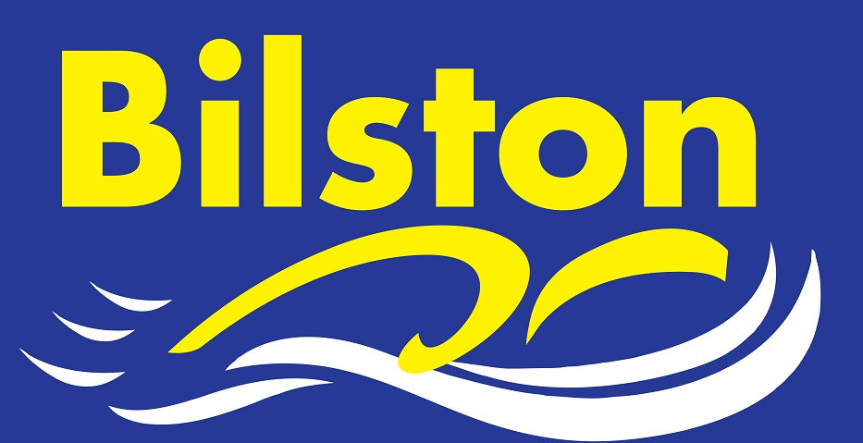
Arena National League

Being in the premier division of Arena National League is a status the club is proud of but it is vital we have a full strength team in round one if we are to stay there. Please make every effort to be available if selected. Whether you are required for individuals or just relays, every swimmer makes a different in this tough league. Thank you. Luke

Long Course Dates for Coventry 6pm – 8 pm, performance swimmers invited £5 pay as you go

19th September
17TH October
19th December

SEPTEMBER 2015

OUR COACHING TEAM 2015/16

The club is delighted to announce changes to our coaching set up for the coming season. Kim Dean, a former national swimmer for Bilston, has agreed to take on the responsibility as our junior coach. She will be working Monday to Friday with our development swimmers on Mondays and Tuesdays and our junior performance swimmers on Wednesday, Thursdays and Fridays. Pauline will continue to work 5 sessions per week with our development swimmers. Kerry, Hayley, Derrick, June, Nicky, Ajay and Eleanor will also continue to support with the coaching of our development group. After a successful trial period, Ryan Gutteridge, a former Bilston swimmer and national level swimmer, will continue to coach on two evenings per week. He will coach our senior performance swimmers on a Monday evening and coach our juniors at Willenhall on a Thursday.

More excellent news is that Mitchell Page will also be increasing his coaching role with us this season. Mitchell, who competed at nationals himself in 2014, will be coaching 4 days per week on Mondays, Tuesdays, Fridays and Sundays. His focus will be with our junior performance swimmers on Mondays(Willenhall), Tuesdays and Sundays and he will assist Luke with the senior performance swimmers on a Friday.
Sara Gamble will also continue to provide her valuable services and coach as and where required for the club and Gary Price will be continuing with the Friday session.
Luke will coach 7 sessions per week but will be covered by Ryan on a Monday evening.

Sponsorship

If anyone thinks their workplace would be able to help us with any sponsorship we would be delighted to hear from you. The club has sent out over 50 letters to local businesses in Bilston asking for sponsorship during the school holiday period.

Congratulations Eleanor and Ellie

The club is delighted to inform members that both Eleanor Harley and Ellie Beddoe-Purchase have recently passed their level one swimming teaching qualification. Both girls work tirelessly in our swimschool each week.

Good luck to all swimmers for 2015/16 season. Let’s work together to make it Bilston’s best ever year! Luke

