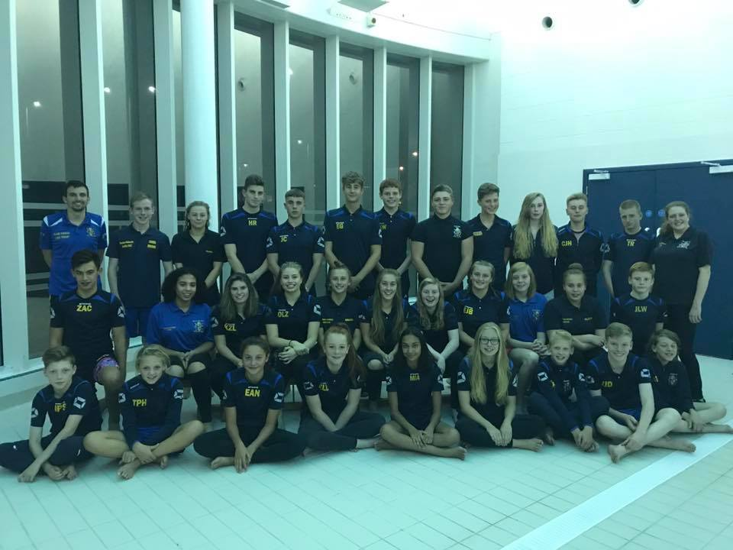
PERFORMANCE
LOG BOOK

SEASON 2017 - 2018

_________________________________________________

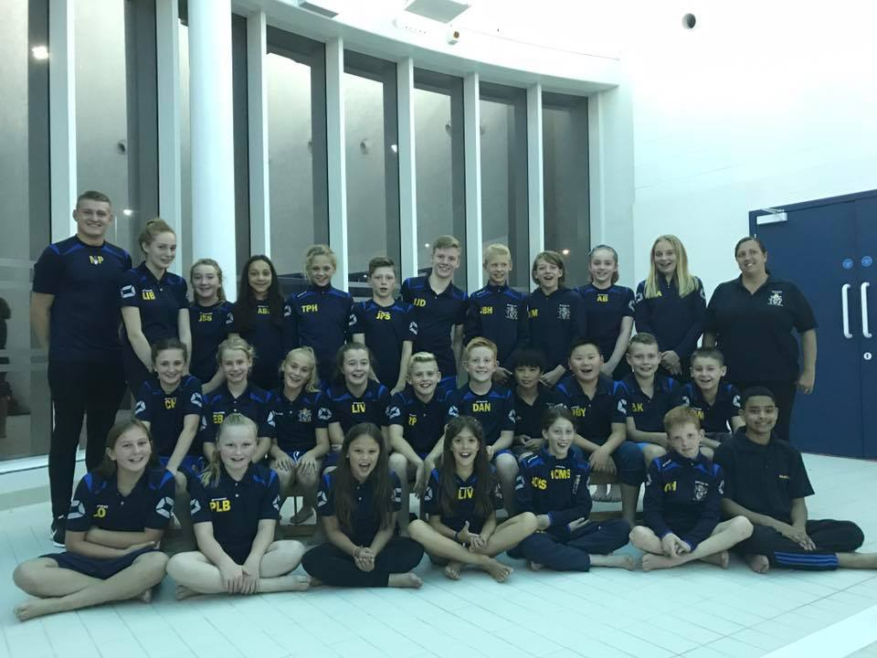
PERFORMANCE
LOG BOOK

SEASON 2017 - 2018

_________________________________________________

ABOUT ME

Name:
Address:
Home Tel No:
Mobile Tel No:
DOB:
ASA Registration Number:
I joined Bilston SC in:

WHY HAVE A LOG BOOK?
The logbook is for you to record all of your personal best times as well as all competition results from galas and open meets that you may compete in.
It is also a place where you can record your height and weight on a monthly basis so that we can track your progress against your physical development.
Coaches will comment in logbooks three times per year during the CHRISTMAS, EASTER AND SUMMER holidays. Coaches will only write in logbooks that have been maintained by you – this means PBs and competition results must be up to date in addition to attendance and some record of your height.
Your latest times and attendance can be found by visiting the club’s website – www.bilstonsc.co.uk. In order to log on you will need your ASA number and a password. Your initial password when using the site for the first time is sw1mm1ng but this can be reset by you at any time. If you have any problems logging onto the website then please do not hesitate to contact me – lukerichardtrout@hotmail.co.uk.
This log book also contains important information such as:
- Club fixture list for the year
- Club Performance Targets
- ASA Competitive Swimming Award qualifying times (check these times against your PBs regularly to see if you qualify for an award)
- Staffordshire County Qualifying times (these are the times you need to compete in a major swimming competition in February each year)
- Midland Qualifying times (this is the next step from Staffs qualifying times and these take place in May/June each year)

Communication of club events (training cancellations, galas, open meets etc) will be via the club noticeboard, club website, text messaging and email as well as through parents meetings. The club has worked exceptionally hard to improve its communication in recent years but we are always striving to be even better.

One final point - Please remember that it is not up to your parents to keep this log book up to date, it is your responsibility!!

BILSTON SWIMMING CLUB
COACHING TEAM
HEIGHT AND WEIGHT RECORD

 | Height | Weight (optional)
Christmas 2017
Easter 2018
Summer 2018
Christmas 2018
Easter 2019
Summer 2019

Please keep a record of your height over the course of each season as tracking your performance in the pool against your physical development is useful to coaches.

MY PERSONAL BEST TIMES

FREESTYLE

DATE & PLACE | 50m | 100m | 200m
Date & Place | 400m | 800m | 1500m
MY PERSONAL BEST TIMES
BACKSTROKE
DATE & PLACE | 50m | 100m | 200m

MY PERSONAL BEST TIMES
BREASTSTROKE
DATE & PLACE | 50m | 100m | 200m

MY PERSONAL BEST TIMES
BUTTERFLY
DATE & PLACE | 50m | 100m | 200m

MY PERSONAL BEST TIMES
INDIVIDUAL MEDLEY
DATE & PLACE | 100m | 200m | 400m

CLUB TIME TRIALS RESULTS

From time to time the club will hold a time trial night. This is a further opportunity for you to attain the qualifying times for the targeted meets during the year.

DATE | EVENT | TIME
MY ATTENDANCE

Please make a note of the number of sessions you attend each month.

MONTH | Number of sessions
September
October
November
December
January
February
March
April
May
June
July
August
COACH’S PAGE

This page is for the coach to set targets and give advice for you future development

Date: __________________________

COACH’S PAGE

This page is for the coach to set targets and give advice for you future development

Date: __________________________

COACH’S PAGE

This page is for the coach to set targets and give advice for you future development

Date: __________________________

QUALIFYING TIMES
The next few pages outline the qualifying times for....

- Staffordshire County Swimming Championships (age 10+)

This meet is held in February each year over 4 days and you should constantly check to see how close you are to achieving these times.

- Midland Age Group Swimming Championships & Midland Youth Championships (ages 11+)

This meet is held in June each year and it is the next step and it is the next level up from the Staffs County Championships. The qualifying times for this meet are very difficult but you should know what they are so that you have something to aim for.

- Midland Short Course Championships

This meet is held in November each year and is for senior swimmers only.

Whole Club Performance Targets
2017/18

- To win the Staffordshire Swimming League
- To finish as high as possible in the premier division of the Arena League
- To attain a top 6 finish in the Nuneaton Junior Swimming League
- To take at least 50 swimmers to the Staffordshire County Championships and aim to be in the top two club clubs overall at the meet
- 24 members to attain Midland Qualifying times
- To have representation at the British Summer Champs and the ASA Summer Nationals

TEST SET RECORDING

In order to determine whether swimmers are making improvements in their speed, fitness and endurance we carry out test sets that are repeated on several occasions over a 12 month period.

- 200m timed kick max
- 30 x 100m best average swim
- T30 swim

Please record your results on the following sheets so that you and your coach can monitor your progress.

TEST SET RECORDING

200 TIMED KICK
Date: |  | Time:
30 x 100m BEST AVERAGE |  | 4 x 15m DK UW
Date: |  | Date:
Average: |  | 1
 |  | 2
 |  | 3
 |  | 4

TEST SET RECORDING

200 TIMED KICK
Date: |  | Time:
30 x 100m BEST AVERAGE |  | 4 x 15m DK UW
Date: |  | Date:
Average: |  | 1
 |  | 2
 |  | 3
 |  | 4
1500m Time Trial

DATE:

50 |  | 800
100 |  | 850
150 |  | 900
200 |  | 950
250 |  | 1000
300 |  | 1050
350 |  | 1100
400 |  | 1150
450 |  | 1200
500 |  | 1250
550 |  | 1300
600 |  | 1350
650 |  | 1400
700 |  | 1450
750 |  | 1500
 |  | TIME
800m Time Trial
DATE:

50 |  | 450
100 |  | 500
150 |  | 550
200 |  | 600
250 |  | 650
300 |  | 700
350 |  | 750
400 |  | 800
 |  | TIME

LAND TRAINING

Name: ____________________________
Review Date: _______________________

GOALS – Season 2017/18

Please think about the next 12 months and write down three things that you want to achieve in the sport.

Goal 1:
How will you achieve this goal?

Goal 2:
How will you achieve this goal?

Goal 3:
How will you achieve this goal?

