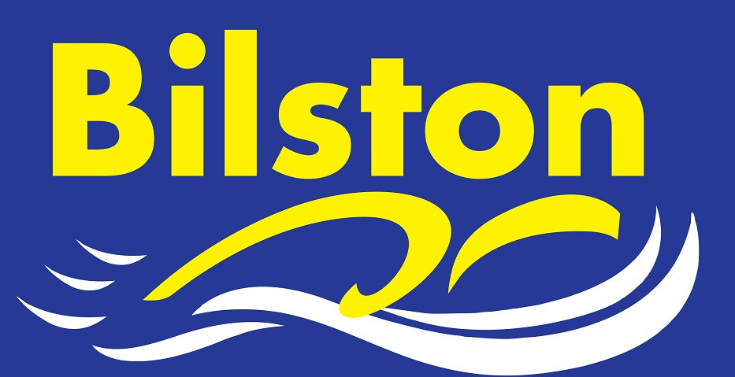
Arena National League

Thank you for your support in the first round of this years Arena League. We stormed the first round and have easily secured our premier status for another year. The clubs record ever finish is 9th-we must aim for this now!!! Please make yourselves available for rounds 2 and 3 if selected.

Long Course Dates for Coventry 6pm – 8 pm, performance swimmers invited £5 pay as you go

17TH October
19th December

OCTOBER 2015

Changes to Midland Champs

The East and West Midlands are splitting this season and this should increase opportunities for our swimmers to compete at district level. Qualifying times will be available shortly.

Club AGM

The clubs Annual General Meeting will be held on Wednesday 2nd December at 7pm in the meeting on the first floor at BW leisure centre. All are welcome to attend.

Club Championships

Forms are now available for the club championships on Sunday 22nd November. Entry is free of charge but no entries will be allowed on the day of the meet. You can withdraw from events on the day but
you cannot enter into them.

Sponsored Swim

Thanks to everyone who took part in the sponsored swim in September. Hopefully lots of money will be raised to help the club. As soon as all money has been collected we will announce a total.

Decision on morning training is imminent

We should have a decision on whether our application for morning sessions at Bilston has been successful any day now. Watch this space!

