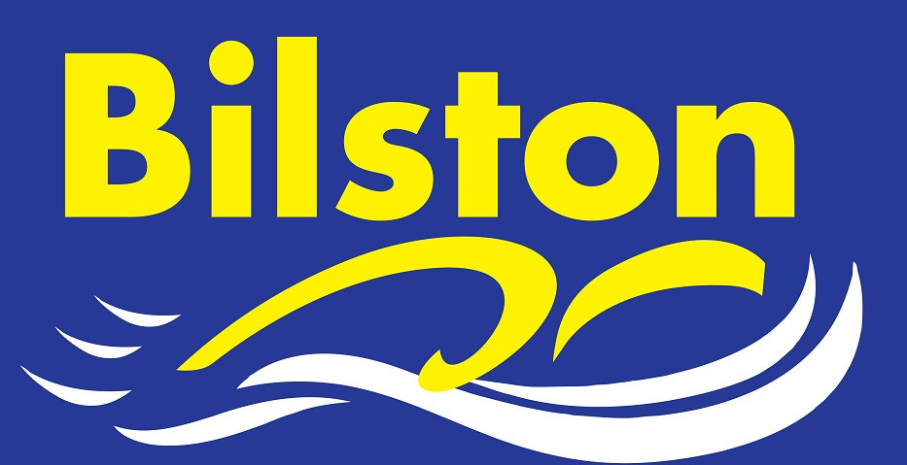
Arena National League

Being in the premier division of Arena National League is a status the club is proud of but it is vital we have a full strength team in round one if we are to stay there. Please make every effort to be available if selected. Whether you are required for individuals or just relays, every swimmer makes a difference in this tough league. Thank you. Luke

Long Course Dates for Coventry for performance swimmers – sign ups will be on noticeboard. (all Saturdays)

19th November 10 – 12 noon

NOVEMBER 2016

LEVEL FOUR LICENSE GRANTED

The club is pleased to announce that it has been granted a level 4 license to run a time trial event here at the Bert Williams Centre. This will give all of our swimmers a further opportunity to gain county qualifying times.
Further details around this meet will be available shortly so please look out for them.

SPECIAL GENERAL MEETING

A Special General Meeting has been called for November 9th to elect a new committee following the recent resignation of the club chairman. Sign up for committee is currently on the noticeboard and anyone who has been a member of the club for 6 months can apply to join. All members welcome to attend this meeting.

CLUB CHAMPS

It is with delight that I can announce that 82 swimmers have entered the club championships – this represents a new record for our club. We now need more volunteers to sign up on the club noticeboard to ensure that the event is a success.

GETTING QUALIFIED OFFICIALS

In view of the recent cancellation of the Chase Open Meet, I will be asking committee to make getting more qualified officials a priority in the next 12 months. We are often the largest competing club at open meets in the local area and we currently are not able to provide our fair share of officials to help the meet run. If you think you may be interested in qualifying as an official then please express your interest to the club desk on a Tuesday or a Friday.

Short Course Midlands

Good luck to Harry Richards and Kiera Langley who will be taking part in the Midland Short Course event on November 5th and 6th.

