
Long Course Dates for Coventry 6pm – 8 pm, performance swimmers invited £5 pay as you go

19th December

NOVEMBER 2015

Club says goodbye to four of its most loyal members
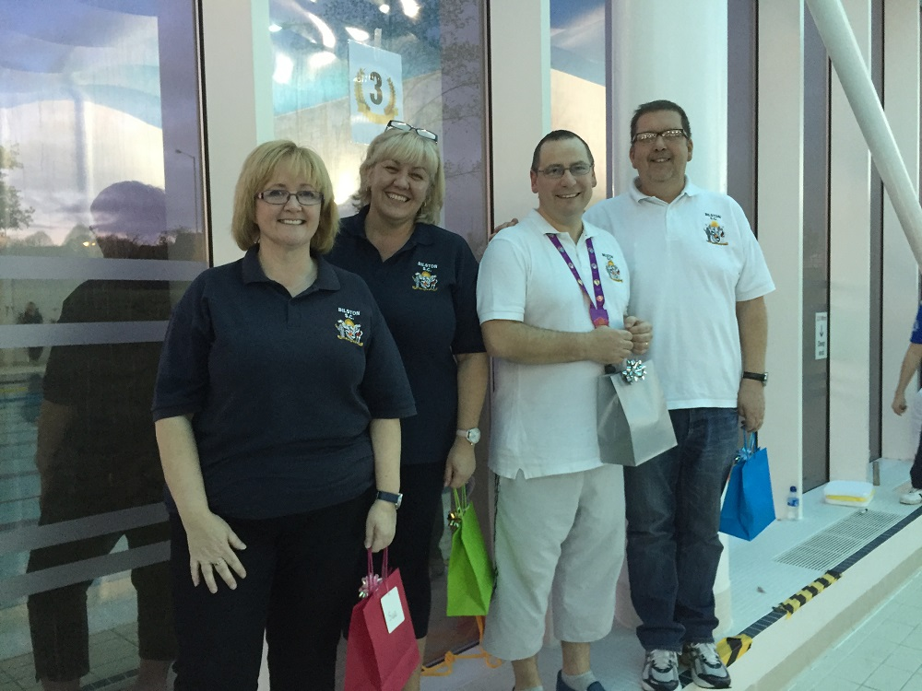
It is with a heavy heart that the club says goodbye to Lyndon Probert and John Lockley (Chairman and Vice-Chairman) and to Joanne Probert and Sue Lockley (Swimschool, membership secs, swimshop) at the end of the year.
During Lyndon's seven year premiership as club chairman, the club has gone from strength to strength. He has overseen membership rising to record levels, negotiated the clubs best ever contract with Wolverhampton City Council and led the most stable and united committee in the clubs history. Joanne has also worked tirelessly on committee taking various roles including open meet secretary and the club shop. John and Sue have been a formidable team transforming the club's swimschool into the vibrant and successful venture that it is today. John as Vice-Chairman has ably assisted Lyndon and shown clear vision and determination to keep moving the club forward.

Above all, these four people have shown unquestionable loyalty to the club and always held the interests of the club ahead of their own.

They will leave a huge hole when they go and will be missed dearly.

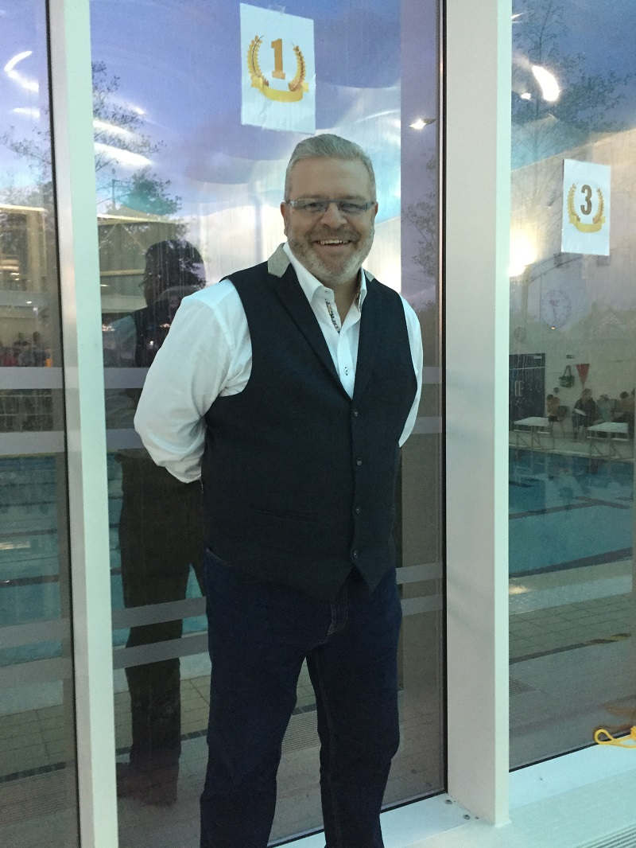
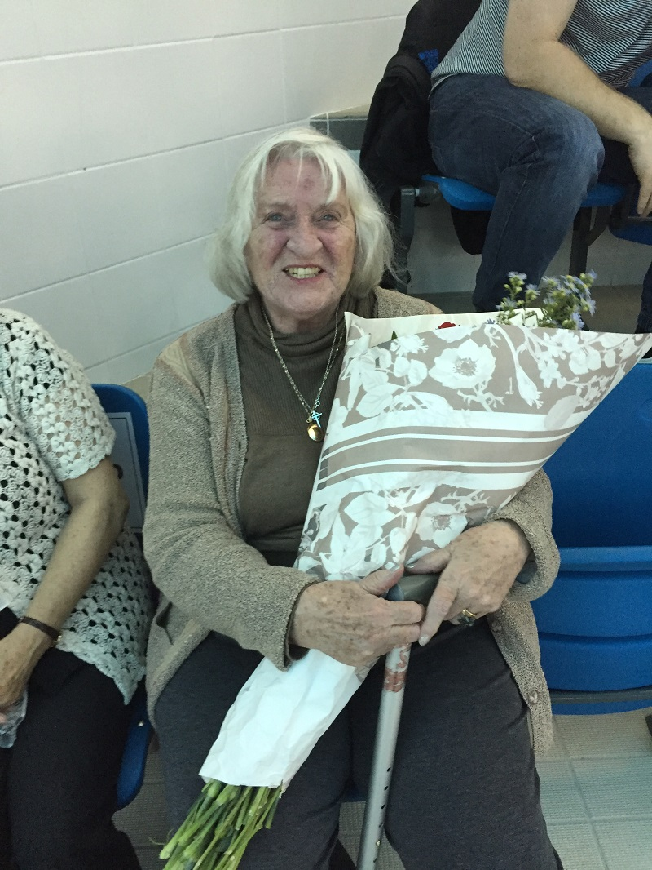

Club President Gary Cattell and life member Sylvia Wellings received a presentation of thanks(above) at the club championships. Gary Cattell works tirelessly in our swimschool and has always shown 100% loyalty to our club. Sylvia has served the club for over 50 years and enjoyed seeing our youngsters perform. Thanks to both for their continued hard work and support.

PB GALORES AND CLUB RECORDS AT THE CLUB CHAMPIONSHIPS

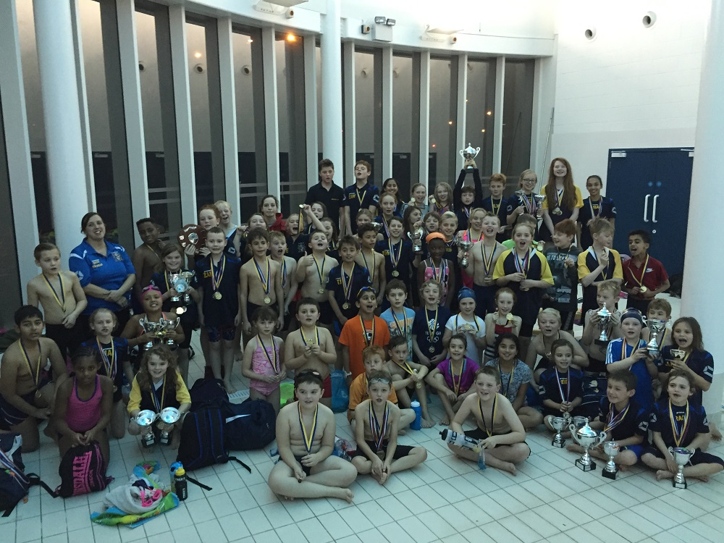
A record number of swimmers took part in our annual club championships event at the Bert Williams Leisure Centre. A massive congratulations to all swimmers who competed during the afternoon - it was an absolute pleasure and privilege to watch.

Records were broken in the Boys 12 yrs & under IM by Zak Westwood, the girls 8 years and under 25m Butterfly by Lily-Ann Dean and the girls 8 years and under 25m Freestyle by Emily Tite.

All swimmers received a medal for their efforts at the end of the competition.

Many sincere thanks to all of the volunteers that helped to make todays event possible.

