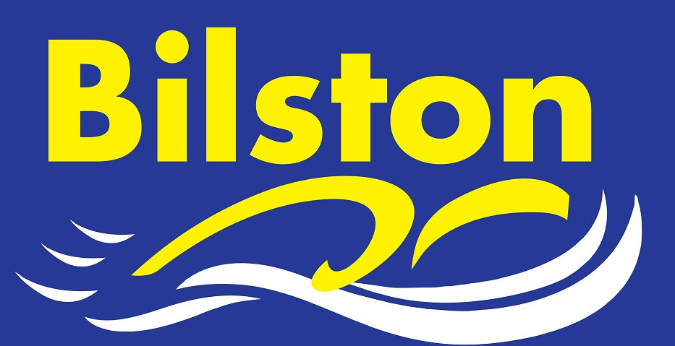

MAY 2017

Regional Round Up.

17 Bilston swimmers represented the club fantastically well at the recent West Midland Championships in Coventry. In total, we enjoyed 96 personal best times, 9 of our swimmers made finals (Zak Westwood, Jack Westwood, Tegan Hands, Joel Hands, Jake Daly, Kiera Langley, Jack Cox, Harry Richards and James Shevchenko) and 4 of our swimmers won medals – these were Kiera Langley, Jack Cox, Harry Richards and James Shevchenko.

Big thanks to Mitch who supported the swimmers over the five days and well done to all swimmers.

James Brown qualified for final at International Para Swimming Championships

Bilston swimmer James Brown enjoyed the best week of his swimming career so far when he PB’ed in all events at the highly competitive para-swimming chammpionships at Ponds Forge. The highlight for James was qualifying for the final of the 400m freestyle following a 17 second PB in the heat. Well done to James on this awesome achievement and keep working hard.

Zero Tolerance on electronic devices at Bert Williams Centre

Swimmers and parents are reminded that electronic devices are not allowed within the pool area and changing village at BW centre. Any swimmer found with a device may be asked to leave the centre and face further sanctions from the centre/club committee.

Nine Bilston swimmers selected to represent Staffordshire at three counties gala

Bilston has the largest representation of swimmers at the upcoming three counties gala in July. Well done to Chloe Harris, Megan Dean, Kiera Langley, Niamh Hofland, Zak Westwood, Jack Westwood, James Shevchenko, Aidan Moore and Matthew Harris.

