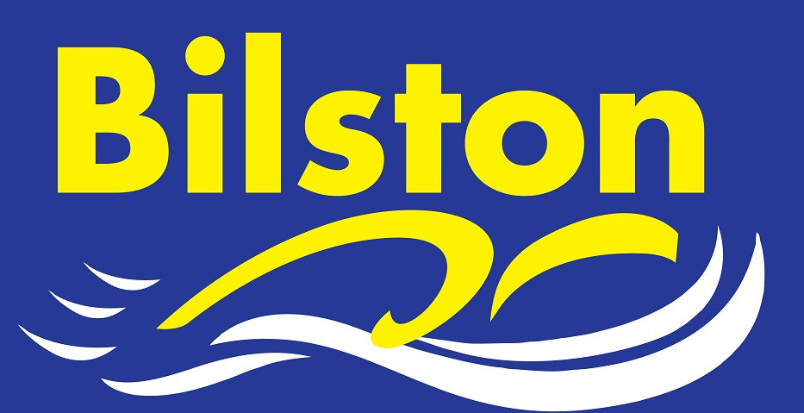

MAY 2016

Gold for Kiera at Regional Youth Championships

Kiera Langley became the club’s first regional champion in 15 years when she won the 100m Butterfly in a new personal best time. Kiera also won silver in the 200m Butterfly and made the final of the 50m Butterfly. Harry Richards won silver in the 100m Backstroke while Brad Price claimed three bronze medals in the 50m Back, 50m Breaststroke and 100m Breaststroke. Taylor Hodges and Holly Lewis also made finals.

Record number of regional qualifiers
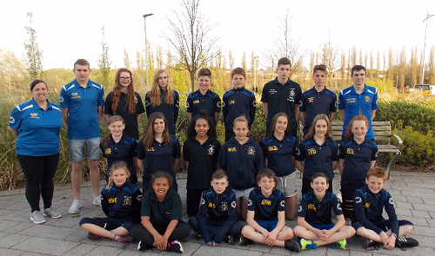
Congratulations to our 23 regional qualifiers for the 2016 West Midland Swimming Championships.
This surpasses the clubs total of 21 in 2014 and all of the coaching staff are extremely proud of their achievements.
Our age group swimmers compete later this month.

Age Group Qualifiers: Eve Williams, Aidan Moore, Lexie Woollery, Isabella Gillott, Thomas Harris, Luke Grimley, Megan Dean, Sian Ellis, Chloe Humphries, Zak Westwood, Jack Westwood, Cieran Pegg, James Shevchenko, Ellie Cox
Youth Qualifiers: Harry Richards, Holly Lewis, Kiera Langley, Lydia Brindley, Brad Price, Taylor Hodges, Tommy Bergin and Aaron Crinnian, Jack Cox

James Brown selected to represent Central England in UK School Games

Congratulations to James Brown who will be one of only four para swimmers to represent Central England in the UK School Games to be swam in Sheffield. Congratulations to club member Niamh Hofland who has also been selected to compete.

Great start made in Junior League

Bilston’s junior team finished 3rd in the first round of the junior league despite not being at full strength. Preparations are well under way for the second round to be held at the Pingles Leisure Centre.

