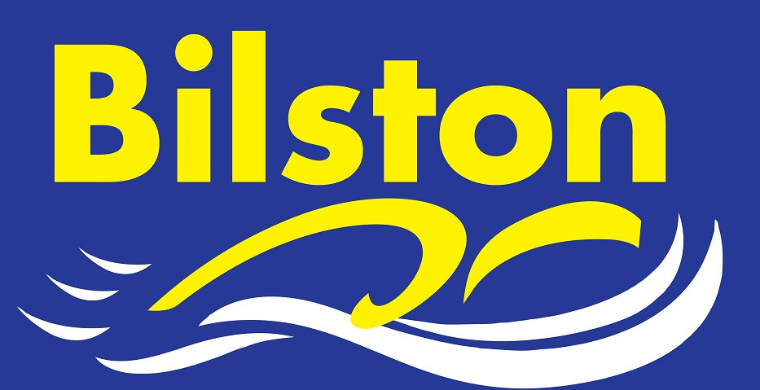

MARCH 2016

Success at County Championships and Staffs League Round One

Bilston’s 58 swimmers impressed at this year’s county championships. There were almost 400 personal best times achieved over the 5 days of competition and dozens of medals won across the age groups. Particularly impressive was the attitude of the swimmers to the dry land warm ups and the sensible use of the swim down facility. It was also pleasing to see more swimmers eating the right things on poolside. We will have a debrief about the county championships following the county relays later this month.

In the Staffs League, both the A and B team won their first rounds. Two impressive displays saw the A and B team both score over 200 points. All swimmers should be very proud of themselves.

Mitch Page qualifies as a Level Two coach

Congratulations to Mitchell Page who is now a fully qualified level two coach. Bilston SC remain committed to training its staff to ensure we have the most skilled possible coaching and teaching staff.

Cardiff Training Camp

There are still places available on the Cardiff Long Course Training Camp taking place during the Easter holidays. Please leave a £20 deposit with Julie Westwood if you would like to go or speak to Luke Trout for further details.
For those that have already paid their deposit, please remember that the balance of £50 is due by the end of March at the absolute latest.

JUNIOR LEAGUE AND MERCIAN LEAGUE

Bilston have been drawn at Leamington Spa for both the Junior League and the Mercian League first round. Coach travel will definitely be provided for junior league gala and a request will be made to committee for the Mercian League also.

