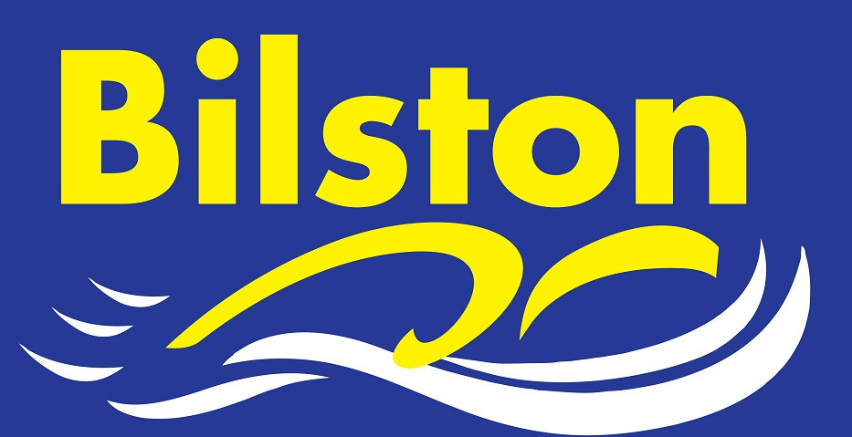

JULY 2017

Top half finish in Junior League

Congratulations to our amazing junior team on their top half league finish in the premier division of the junior league. Despite some tough draws, the team more than held their own against some high quality opposition. There are some proposed changes to the league next year meaning that the premier division could be reduced to 18 teams – even if this happens in 2018, our place in the top division is secure. Thanks to Kim for ensuring the organisation of all three galas went so well and results were posted promptly.

James Brown selected for level 2 of England Talent Para-Swimming Programme

As a result of James’ hard work and excellent results in the pool this season, he has been selected for the next stage of the talent programme. James started in the clubs swimschool and he has made wonderful progress ever since – he will be representing the club at the upcoming ASA English Summer Nationals in August.

Former coach, Jason Shepherd, sadly passes away

It is with regret that we have to announce that former coach Jason Shepherd passed away recently following a short illness. Jason worked at the club on a 100% voluntary basis despite not having a child that trained with us. He gave nearly 4 years of service to the club and was a very popular coach here during his time. The club does intend to make a donation.

Aidan, Eve and James represent the club at regional open water event

Well done to Aidan Moore, Eve Lewis and James Lewis who did a great job in the 1,5k open water event in Bosworth. We are still waiting for results to be posted but all three swam brilliantly well.

Sponsored Swim

The club plans to run a sponsored early in the new season to raise funds for the club moving forwards. Details on the club noticeboard now.

