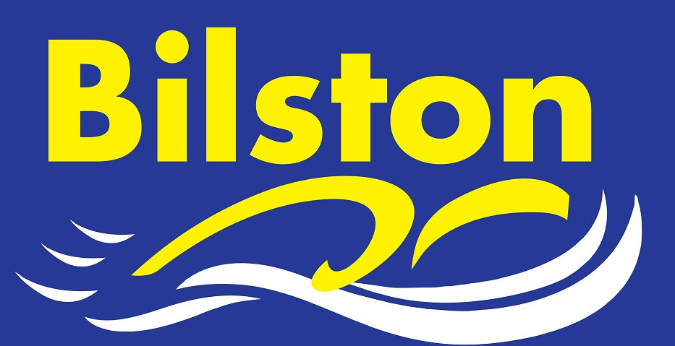

JANUARY 2017 – HAPPY NEW YEAR!!!

MAKING 2017 THE BEST YEAR EVER!!!

The club is in the process of reviewing its business plan in order to ensure that we can keep moving forwards in the coming year and beyond.
The determination of the coaching/teaching staff and the club committee will be relentless in ensuring that our all of our members get the best possible deal. Thank you all in advance for your continued support.

72 COUNTY TIMES IN HUGELY SUCCESSFUL LEVEL FOUR TIME TRIAL

The club organised and ran its first ever licensed time trial event in December and it was certainly worth as dozens and dozens of county times were achieved in addition to many more personal best times.
Despite the short time scale, Lou Taylor and Lisa Pegg managed to get a licence for the club and organise the training of the all the required officials to make the day a success.
Thank you to all that contributed to help make the day successful.

ENGLAND TALENT SELECTION FOR JAMES BROWN

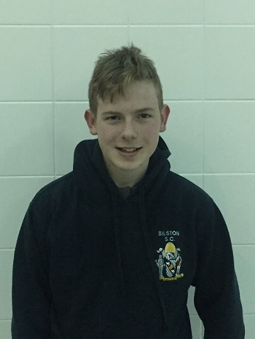
Congratulations to Bilston swimmer, James Brown, who has been offered a place on the ASA Para-Swimming Foundation Programme.
Jame's incredible personal best time times at the recent National Para- Swimming Championships in Manchester triggered the selection - the highlight being winning a bronze medal in the 400m freestyle.
The coaching staff are proud of his hard work, perseverance and determination.
Well done James!!!

