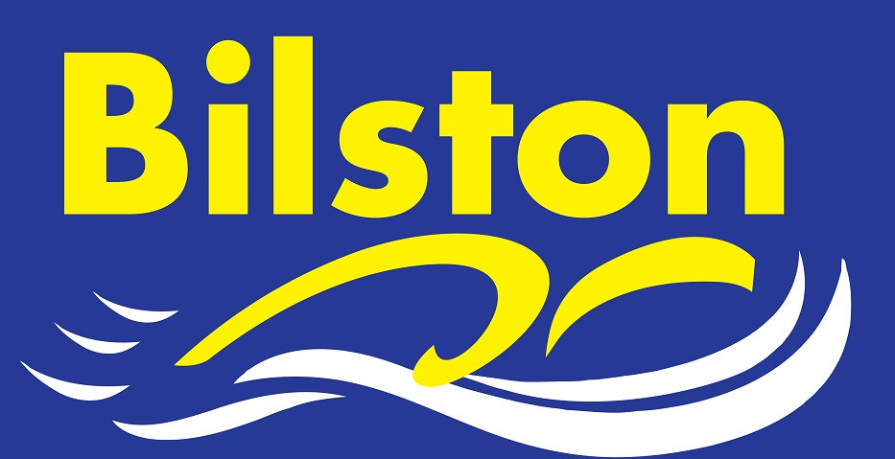

FEBRUARY 2017

Marie Russon qualifies as Level One Teacher
Congratulations to Marie who passed her level one qualification in January. Marie works on the main pool and our swimschool and has quickly become an invaluable asset to the club.

Win for junior team in friendly gala

Congratulations to our junior team who won their first gala of the season – a super effort from all. There will be one more preparation gala in March before the Junior League starts in April. Kim will shortly be starting the process of selecting the team captains for this years compeititon.

Staffs County Champs 2017

We have the most swimmers and greatest number of entries at this years county champs. Well done everyone. Let’s hope we can now challenge to win the meet overall with a club record point score!

Great attendances

Thank you for the superb attendances over the last month. I am sure we will see some incredible progress from all of our swimmers in the coming meets and galas.

Thanks to development parents

A huge thank you to our development parents who attending the meeting to discuss competitive swimming. We appreciate your continued support and hope that you found some of the information useful.

