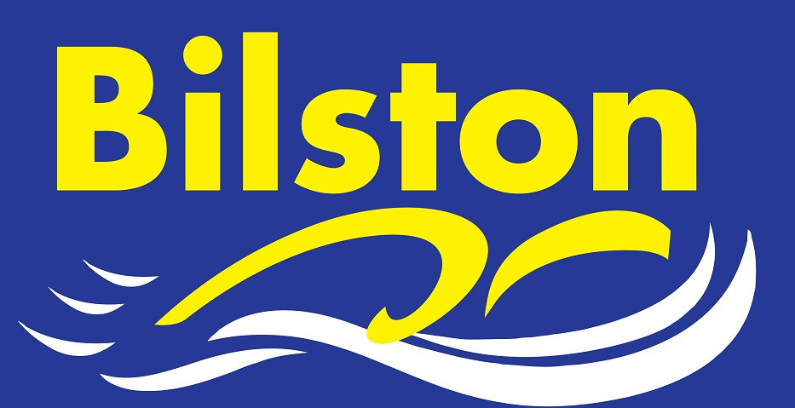

FEBRUARY 2016

Cardiff Training Camp

There are still places available on the Cardiff Long Course Training Camp taking place during the Easter holidays. Please leave a £20 deposit with Julie Westwood if you would like to go or speak to Luke Trout for further details. This camp is open to all performance swimmers.

For those that have already paid their deposit, please remember that the balance of £50 is due by the end of March at the absolute latest.

County Championships

February is an exciting month for the club as 58 swimmers will be representing the club in Stafford at the Staffordshire County Championships. This year, we have more swimmers that any other club and the coaches are more confident than ever before about how well our swimmers will perform. It promises to be a very exciting three weekends of swimming.

Email/text updates

If you are not receiving email/text updates from the club then please leave your details at the club desk so that you can be added to the mailing list. Also, remember that any session cancellations will always be posted on the club website.

Junior Captains

Kim Dean will soon be holding a vote to decide our junior male and female captains for the 2016 junior league season which starts at Leamington Spa in April. As ever in the top division, the first round draw is extremely tough so please make every effort to be available if selected. There will be coach travel provided for this round. We are also the organising club for round one so if you are willing to volunteer or help in any way then please see the club desk on a Tuesday or a Friday.

A BIG THANK YOU TO ALL SWIMMERS THAT HAVE MADE THAT EXTRA EFFORT TO ATTEND AS MANY SESSIONS AS POSSIBLE BEFORE THE COUNTY CHAMPIONSHIPS – I HOPE YOU ARE REWARDED WITH FAST TIME!!!

