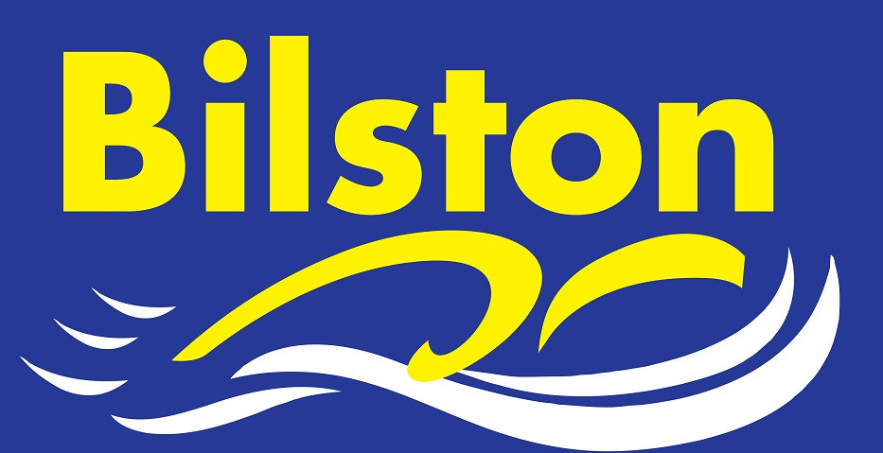

DECEMBER 2016

CHAMPIONS OF STAFFORDSHIRE
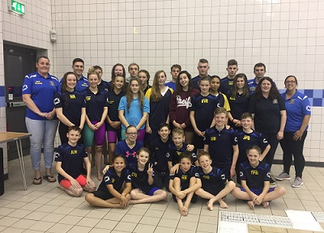
Bilston win the Staffs League for the fourth time in five years in a close final at Stafford B team finish 11th overall out of 18 teams.

Bilston rewarded Courteney Price for her 8 years of representation for Bilston in this league by making her captain for the evening. The trophy presentation will be made at the club time trial night.

TOP HALF FINISH IN ARENA LEAGUE PREMIER DIVISION

Bilston not only secured their status in the premier division of the Arena League but have also attained a top half finish putting us amongst the very top clubs in the region. Brilliant news!!!

TOP CLUB FOR BILSTON AT WYRE FOREST MEET
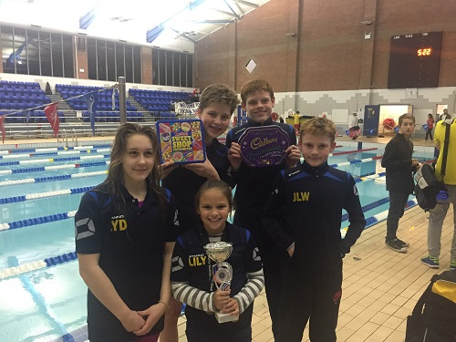
Over 50 swimmers competed at Central Baths and secured the top club award in the process.
Dozens of county qualifying times were achieved in addition to nearly 200 PBs and several regional qualifying times. James Shevchenko was top boy at the meet!
Thanks to our team managers and officials who continue to give freely of their time to support the club in events like these.

CLUB CHAMPS – 5 CLUB RECORDS SMASHED
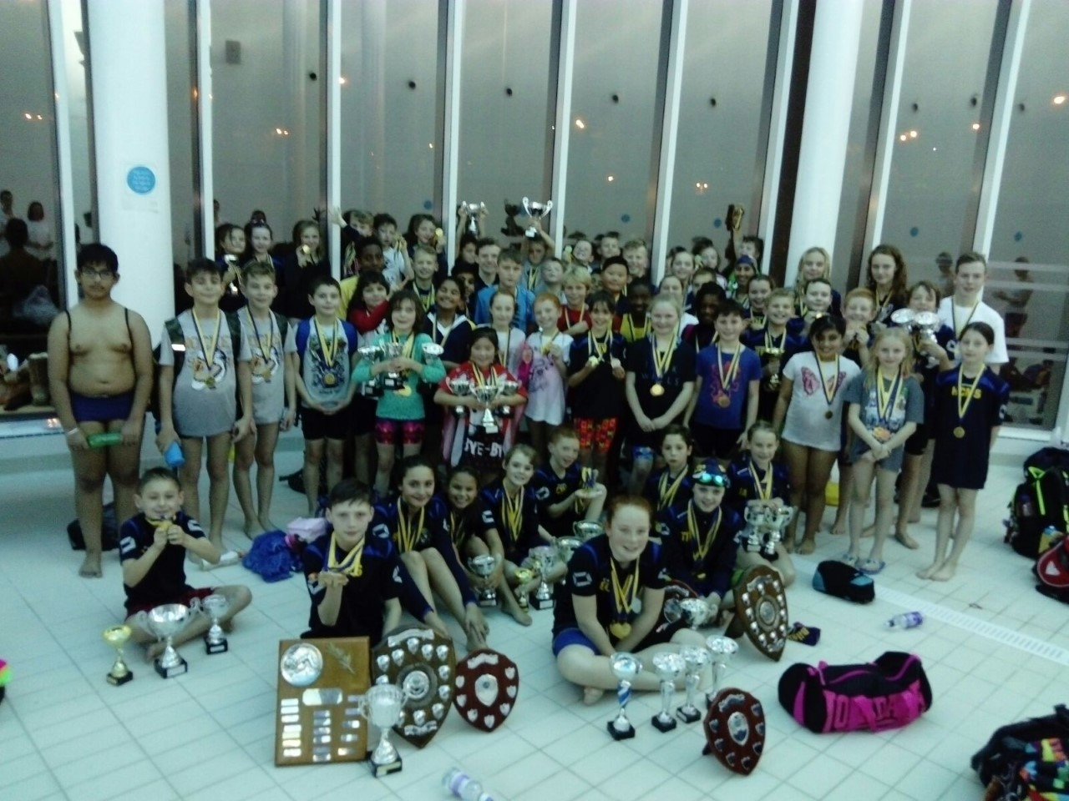
5 club records were broken in an action packed club championships event. In a record year for entries the club organised one of its best champs yet. Thanks to all for your support to make this happen.

