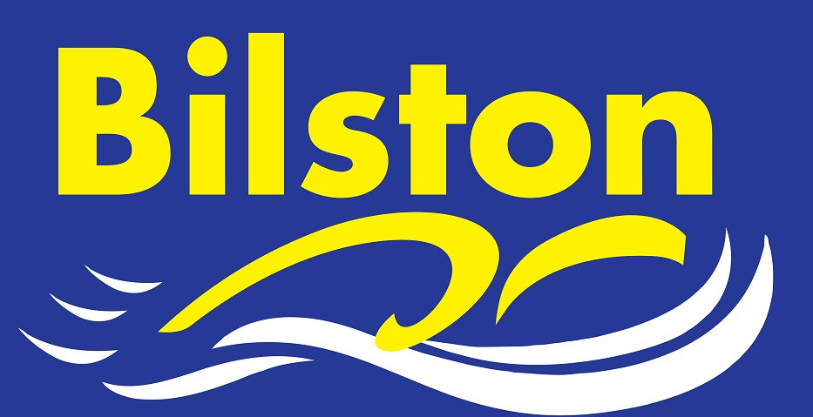


DECEMBER 2015

Top half finish for Bilston SC in Arena Premier Division

Congratulations to the 32 swimmers that represented the club in this year’s Arena League. The club secured a second place finish in the final round of the competition, a result which means the club finish in the top half of the table, The club is proud of its top division status in both the Arena League and Junior League – we are the only club in the county to be in the top division of both.

Karl Bourne and Mark Jacques elected as Chairman and Vice-Chairman for 2016

Following the recent AGM, we are pleased to announce that Karl Bourne will take over from Lyndon as the club chairman and Mark Jacques will take John Lockley’s role. The club reported a small surplus for the financial year, mainly thanks to increased revenue from the clubs swimschool

4 medals for James Brown at National Para-Swimming event

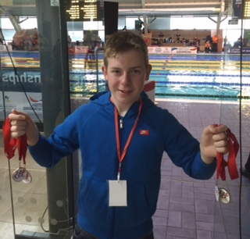
James Brown swam big PBs and won two silver and two bronze medals at the recent National Championships in Manchester. James has now qualified for British Para-Swimming International Meet to be held in Glasgow in 2016. Well done James on this fantastic achievement!

Four newly qualified Level One coaches

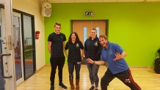
Congratulations to Mitchell Page, Kerry Harris, Tasmin Cox and June Hodges who all passed their level one coaching course this weekend. The club is committed to investing in its coaching and teaching team and all four should be congratulated. June did not want her picture taken however the eccentric instructor clearly did.

