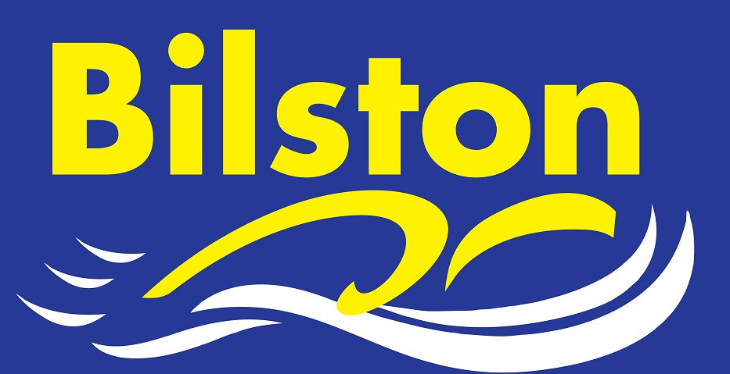

APRIL 2016

21 regional qualifiers and counting…

So far, 20 of our performance swimmers have qualified for the West Midland Championships to be held at Coventry.
Age Group Qualifiers: Eve Williams, Aidan Moore, Lexie Woollery, Isabella Gillott, Thomas Harris, Luke Grimley, Megan Dean, Sian Ellis, Chloe Humphries, Zak Westwood, Jack Westwood, Cieran Pegg, James Shevchenko
Youth Qualifiers: Harry Richards, Holly Lewis, Kiera Langley, Lydia Brindley, Brad Price, Taylor Hodges, Tommy Bergin and Aaron Crinnian

The coaching staff are exceptionally proud of the achievements of these swimmers and there will be a photograph soon for all of our qualifiers.
We had 21 qualifiers in 2014 and I am hopeful that with a few weeks to go that we may be able to break the club record this season. It is very pleasing that this year we have more Youth Qualifiers than ever before- a sign that the strength and depth throughout to learn to swim and junior programme is beginning to bear rewards in the senior programme!

I would like to pay tribute to our hard working teaching and coaching staff working at all levels of the club. We should be proud to be a club that sits in the top division of the Junior and Arena League and currently top of the Staffordshire League. At the recent relay championships, our boys won the meet overall and our girls were second - a further indication that we have strength and depth throughout all the age groups. The club has been operating at 95% + capacity for the past 4 years and we have more qualified staff than ever before. As always, the club strives to improve further and plans are in motion as to how we can move forwards again next season.

A major frustration this season has been the inability to get morning sessions at Bert Williams but rest assured I have not given up and I believe this is a key piece of the jigsaw when looking at how to improve in the months ahead.

Junior Captains 2016

Congratulations to Luke Grimley and Ellie Cox who have been elected as this year’s junior captains. I’m sure that both swimmers will make excellent young leaders within the club and lead by example. I am sure that everyone will get behind them and the junior team this season.

