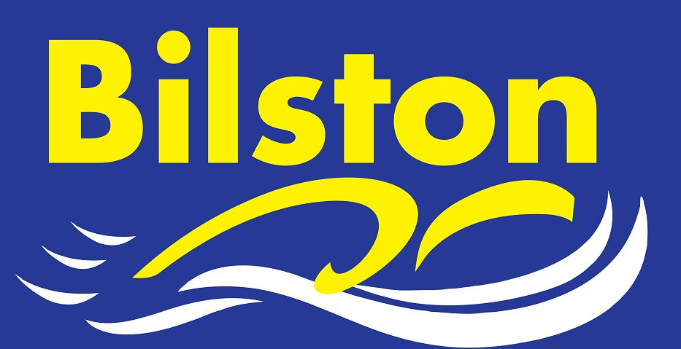

APRIL 2017

Congratulations to our 17 regional qualifiers for 2017 ….

Zak Westwood, Jack Westwood, Ethan Giles, Jake Daly, Aidan Moore, Joel Hands, Tegan Hands, Jack Cox, Harry Richards, Cieran Pegg, Libby Perks, Holly Gregory, Molly Charles, James Shevchenko, Lydia Brindley, Kiera Langley, Zak Howes

We also had a number of swimmers who were just fractions of a second away from qualification but I’m sure this will only make them more determined for next year. Well done to all!!!

Mercian League

The high number of regional qualifiers means we are short of older swimmers for this years Mercian League. This is a good problem to have and it will mean that the league will offer opportunities for children to swim who maybe don’t often get opportunities to compete for the club. We are organising club for round one.

County Qualifying Times

Whilst the county times for 2018 are not out, I have been told that the times are likely to be broadly similar to this year. It was commented that the open age group times may be made harder.

Junior League
Our junior team sits in mid table following a tough first round draw. Our 9s did incredibly well and we are aiming for a top half finish in the premier division this season. Good luck for round 2 guys.

