Please join us in our Sponsored Swim event on
TUESDAY 3rd OCTOBER 2017

Help us raise funds for our club by participating in our sponsored swim event.

At the end of 2011, the club moved into the new ‘Bert Williams Leisure Centre’ a much improved facility for us, but this came with a 95% price hike in pool hire charges from ‘Wolverhampton Borough Council’ in the ensuing 5 year period which resulted in the club having to find a further £25,000 a year to cover costs. We now currently pay out £56,000 a year just to cover pool hire costs.

Funds raised will go towards the hire of the pool, equipment needed/Underwater Camera’s, training of swim teachers/coaches.

The Event will take place instead of the normal swimming session.

Community and Development Swimmers

This is your opportunity to earn and purchase an ASA distance badge award.
The ASA offers badges for the following distances 100m, 200m, 400m, 800m 1500m and 1 mile(1600m).
Your Challenge is to swim the distance of your choice, without stopping and in turn raise funds for our club. You could be sponsored for the whole swim or per length. If successful, you will be able to purchase the relevant badge from the club to add to your collection for £5

*Please note: all distances need to completed with the usual session time.

If interested, Please take a form from the club desk on a Tuesday/Friday evening or simply print the form attached in the email.

You must register your intention to take part on the club noticeboard at Bilston.
Are you up for the Challenge????? 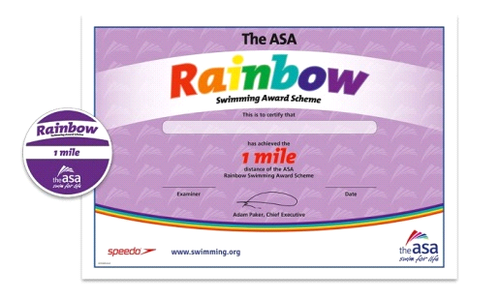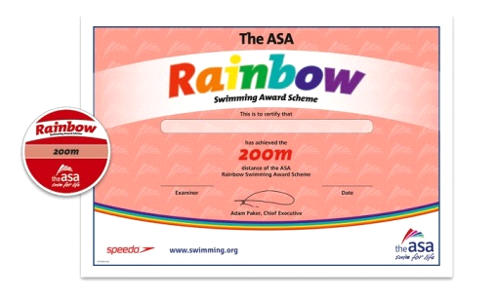
Junior & Senior Performance Swimmers (JP1/JP2/SENIORS)
“The Challenger Deep in the Mariana Trench is the deepest known point in Earth's oceans”
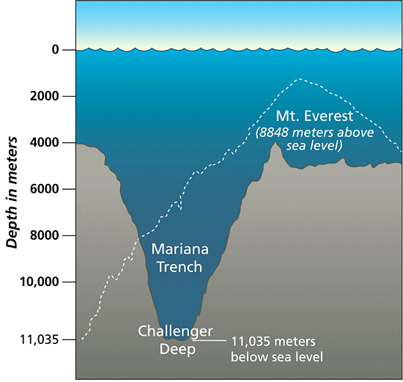
Team Challenge – SWIM the distance of the deepest Ocean “ Challenger Deep ”
(36,200 feet / 6.8miles / 11035metres)
To be completed in Teams of 2-5. Swim must be completed within 2 hours.
Team of 2 : 220 lengths each
Team of 3 : 147 lengths each
Team of 4 : 110 lengths each
* Team of 5 : 88 lengths each (Aimed at JP1- Also 2000m ASA badge can also be purchased if completed)
Senior Performance swimmers must complete the swim wearing clothing/ T-Shirt / Shorts / Pj’s etc…
Ideas: Team colours – t-shirts / team themes welcome. Junior Performance can also wear clothing- optional

If interested please take a form from the club desk on a Tuesday/Friday evening or simply print the form attached in the email.

You must register your intention to take part on the club noticeboard at Bilston.
We hope that as many swimmers as possible will support us and help keep the club moving forwards.
If you have any queries please speak to Kim Dean (Junior Coach) or Luke Trout (Head Coach).
Are you up for the Challenge?????
SWIMMERS NAME..............................
SPONSORED SWIM TARGET (DISTANCE ETC).............................................................
Name | Address | Amount sponsored:  Per length/per swim | Date Received

SWIMMERS NAME..............................
SPONSORED SWIM TARGET (DISTANCE ETC).............................................................
Name | Address | Amount sponsored:  Per length/per swim | Date Received

