Life Member Pauline Trout sadly passes away

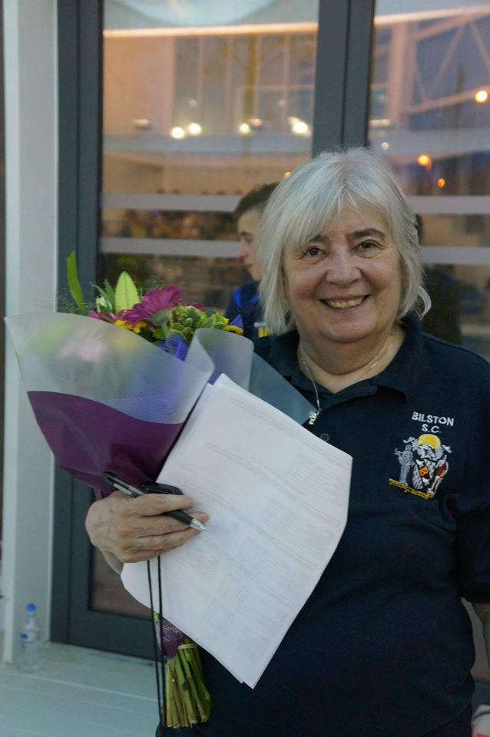
It is with immense sadness and deep personal grief that I have to announce the passing away of life member Pauline Trout following a short illness at the age of 66.

Pauline joined Bilston SC in 1981 and has been a very active club member ever since. Her three children – Adam, Mark and myself – all attended the club as swimmers from the swimschool to senior performance level and since 2010 I have been the Head Coach. Pauline is by far the club’s longest serving coach and her experience will be sorely missed and impossible to replace. In 2014, the committee recognised her dedication and loyalty to the club by awarding her life membership.

As many of you know, Pauline has been coaching on a voluntary basis five times per week at Bilston for over three decades. Her passion and enthusiasm during this time has been undying. Undoubtedly a key factor in the clubs ability to produce brilliant young talent has been Pauline. Her passion was getting our 7 and 8 year olds ready for competitive swimming and in this area she was truly outstanding. Pauline has a unique eye for spotting talent and nurturing potential. This was shown a couple of years ago when we both walked onto poolside together for a session while a council lesson was underway. After watching this lesson for a minute or so, she pointed to the pool at a boy swimming in the lesson and said we need him – he could be brilliant. The boy joined the club shortly afterwards and this year attained his first regional qualifying time aged 10. My mom made a point of reminding me how she could always spot the potential.

However, Pauline’s role was not just the coaching. She has served on the club committee for most of her time at the club and over the years has had many jobs including fixtures secretary, organising the club championships, sorting all league registrations, sourcing pool space, making team selections, team managing at various events around the country amongst many other things. She has also been acting head coach on three occasions when the club needed someone to fill the role.

Her main strength has been her loyalty. She has stuck with the club through the high points and the low points and supported every single Head Coach and Chairman that the club has appointed. Pauline never wanted a promotion, financial reward or constant praise – she just wanted to be poolside coaching week in week out. Testament to this is the fact that she was the best attending coach the club had as she has planned her life around the club for over 30 years. Indeed she continued to coach right up until the point where she physically could not walk up and down the side of the pool anymore. This was because she didn’t want to let me or the club down.

What many of you will not know is that Pauline and I regularly argued about the club and what was the best route forward for Bilston. Every time I wanted to make a change she would play devil’s advocate and really test whether I had fully thought through what I was about to do. Although this led to many heated debates, it was important because Pauline really felt the pulse of the club and she could always see the bigger long term picture over the short term gains. Though doing this, she has taught me to respect the whole club and not just parts of it. Pauline also had many ideas of her own. For example, she inspired the expansion of the junior performance squad last season.

Whilst this is a very sad time, she would want it to be business as usual at Bilston and I will endeavour to ensure that the coming weeks are as smooth as possible. My mom told me back in 2010 that it would be impossible to qualify for a junior league final with so many big squads now allowed in the league – I would love us to be able to prove her wrong. Although she was a huge part of everything that was good about the club, I know that the club can continue to prosper and I am fiercely determined to ensure that this is what happens.

Many thanks for your kind words and best wishes,

Luke Trout
Bilston SC
Head Coach

